Antioch Christian Academy
SCHOOL Bus CONDUCT AND SAFETY

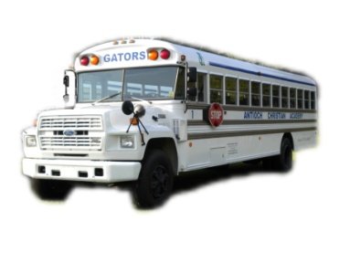
We know that you share our concern for the safety of every student who rides a school bus. We ask you to impress upon your child that it is absolutely necessary to follow the rules and to obey the bus driver. It is very important that you review these rules and responsibilities with your child.

Duties and Responsibilities of Students onVan
All References to the bus, will also indicate van.

Conduct of Students:
* Obey the bus driver promptly concerning conduct on the bus.
* Observe classroom conduct, except for ordinary conversation, while getting on or off, and while
riding on the school bus. Objects such as weapons, chains, sticks, rocks, pets, etc, are not allowed on the
school bus.
* Be at the place designated both morning and afternoon ready to board the bus at the allotted time.
The driver is responsible for maintaining this schedule and cannot wait for tardy pupils.
* Help keep the bus clean, sanitary, orderly, and refrain from damaging or abusing the cushions or
other bus equipment. Students/Parents will be required to pay for damages. Eating/Chewing Gum is not
permitted on the school bus.
* In case of an emergency, calmly ask the driver to stop the bus.
* The use of drugs, alcohol, tobacco, and profane language is absolutely prohibited.

Safety Rules:
* Wait until the bus has come to a complete stop before attempting to get on or off.
* Leave the bus only with consent of the driver.
* Enter or leave the bus only by the front door, except in case of an emergency.
* Do not lean out of windows. Keep head and hands inside of the bus.
* Do not throw objects inside or out of the bus.

School Administration may take away a student’s riding privilege for:
* Fighting, smoking, drinking, using or possessing drugs, using profanity, refusing to obey the driver, etc.
* Entering or leaving the bus without permission of the driver.
* Refusing to be seated or not allowing others to be seated.
* Using the emergency exit when there is not an emergency.
* Changing seats without the permission of the bus driver or Administration.
* Delaying the bus schedule due to conduct.
* Not entering or leaving the bus when instructed to do so.
* Throwing items out of the window or on the bus.
* Distracting the bus driver or participation in any inappropriate behavior while riding the bus.
* Any conduct deemed inappropriate by the bus driver or Administration.
* Suspension or loss of riding privileges will generate NO refunds.

Under General Statute 115C-399 the Principal may prosecute anyone for:
* Willfully trespassing upon or damaging a school bus.
* Entering a school bus or school activity bus after being forbidden to do so; or
* Refusing to leave a bus upon request.

School bus rules and actions of school bus drivers are for the safety of our children. Your support and cooperation are needed.

_______________________________  Student’s Signature | _______________________________  Parent/Legal Guardian’s Signature | ______________________________  Date
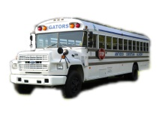
ANTIOCH CHRISTIAN ACADEMY
BUS STUDENT INFORMATION

STUDENT’S NAME:
ADDRESS:
DATE OF BIRTH:
HOME PHONE:
GRADE:
HR TEACHER:
BUS STOP: | (Circle One) Hyde Park Biggs Park Mall Sears
EMERGENCY CONTACTS: Print in order of precedence.
NAME: _______________________________ PHONE NUMBER: ____________________
NAME: _______________________________ PHONE NUMBER: ____________________
NAME: _______________________________ PHONE NUMBER: ____________________
NAME: _______________________________ PHONE NUMBER: ____________________

(To be completed by Bus Driver)

SEATING:
LEFT SIDE SEAT#____________ or RIGHT SIDE SEAT#____________

Window______ Center______ Aisle Seat ______ Window_____ Center______ Aisle Seat _____

